

SUMMER HOLIDAY HOMEWORK 2025-26

CLASS - I

**Subject- English**

Q1- Practice cursive writing one page daily

Q2. Practice reading one page daily from your English book.

Q3-Learn and write 10 domestic animals, birds, fruits, and transports name.

Q4-Write and learn Vowels and Consonants and make a chart on it.

Q5- Match the small letters to the big letters.

B d

D b

F h

H f

P l

L p

X t

T x

Q6-fill in the blanks with a vowel:-

1-b___g 2-C___t 3- p___n

4-p___n 5-s___n 6- b___t

Q7- Complete the following worksheets in your holiday homework **(Fun with Learning)**  book.

(i) Worksheet-1 Colour me

(ii) Worksheets-2 Rhyming words

(iii) Worksheet-3 Vowels and Consonants

(iv) Worksheet-4 Phonics

(v) Worksheet-9 Birthday fun

(vi) Worksheet-10 Describing words

(vi) Worksheet-12 One and many

(vii) Worksheet-19 Opposite words

Q-8 Make a colourful kites with paper and sticks.

**Subject-Hindi**

Q-1 नीचे दी गयी वर्कशीट को अपनी होलीडे होमवर्क **(Fun with Learning)** बुक में कीजिए-

1. वर्कशीट-3,5,6,9,10 - अवलोकन
2. वर्कशीट- 1,14,15 - खेल-खेल में
3. वर्कशीट-8, 11, 12, 13, 19 - वर्णो की पहचान

2- वर्णमाला लिखे व याद करें।

3- आ की मात्रा वाले 10 शब्द लिखिए ।

4- इ की और ई की मात्रा वाले 10-10 शब्द लिखिए

5- 3, और ऊ की मात्रा वाले 10-10 शब्द लिखिए व याद कीजिए।

6-प्रतिदिन दो वर्ण, तीन वर्ण व चार वर्णो के शब्द पढ़कर लिखिए।

7-आ,ई, उ, व ऊ की मात्राओ के शब्दों को प्रतिदिन पढ़े ब अभ्यास करें।

8- कविता की चार लाइन लिखिए व याद कीजिए (पेज न० 21)

9- एक (01) से बीस (20) तक हिन्दी गिनती लिखिये |

**Subject-MATHS**

Q-1 Complete the Following Work sheets in your holiday homework**(Fun with Learning)** book.

(i) Worksheet -1 Bigger / Smaller

(ii) Worksheet -2 Longer / Shorter

(iii) Worksheet -3 Same / Different

(iv) Worksheet -4 Sorting

(v) Worksheet -5 Matching

(vi) Worksheet -17 Before , after, between

(vii) Worksheet – 18 –Comparing <, >, =

(viii) Worksheet -23 Addition (1-10)

Q-2 Learn and write tables form 2 to 20

Q-3 Reverse counting 50 to 1

Q-4 Write the ordinal number from 1st to 20th in your note book.

Q-5 Draw and colour the picture of Five Shapes , Paste it on A-4 size sheet and write their names. (circle, square, oval, triangle, rectangle.)

**Subject-EVS**

Q1- Complete the Following Work sheets in your holiday homework**(Fun with Learning)** book.

(i) Worksheet – 1 to 20

Q2- Write 5 lines about yourself.

Q3- Write 10 lines on The cow.

Activity work-

Q-1 Cut and paste different types of flowers on chart paper

Q-2 Draw and colour a picture of kite in your notebook.

Q-3 Make a family tree and paste photos of your family members

**Subject-Computer**

Q1- Complete the Following Work sheets in your holiday homework**(Fun with Learning)** book.

(i) Worksheet – 1 – Computer (ii) Worksheet – 2 – Parts of a Computer

Q-2– Name the places where computer is used .

Q-3- Write the name of three people who uses computer.

**Project work**

Q1- Draw or paste parts of computer on chart paper and label it

Q2 - Book reading From page no 25 to 55.

**Subject-G.K**

1. Write 7 Flowers name and Paste their Pictures-

2. Write 7 Wild animals name and Paste their Pictures.

3. Write 5 Sense organs name and Paste their Pictures.

4. Make a Colourful Chart on "Road sign?"

5. Give the answer of the following-

(i) National Flag of India.

(ii) National Animal of India,

(iii) National Fruit of India.

(iv) National flower of India

(V) National bird of India

(vi) Write the name of any two festivals.

**Subject – Drawing**

Q- 1 "Practice writing A to Z calligraphy letters in your notebook with the help of given examples.

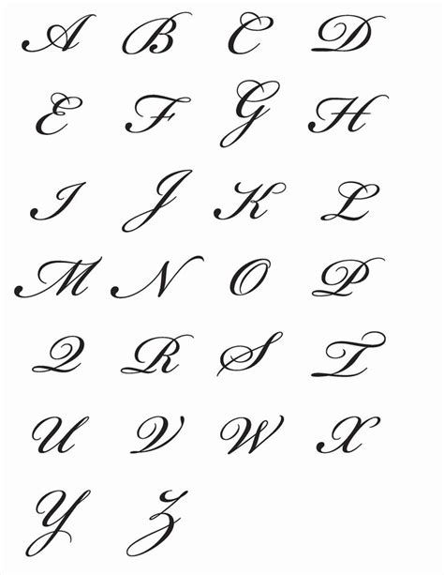

**Creativity corner :-**

**Prepare a Father’s day card, give it to your father and take a short video or pictures.**

1- Father' day Celebration on 15 June 2025

**Prepare a short video or take pictures related to any one activity**

1- Environmental day Celebration on 5 June 2025

2- Use any recyclable material like - plastic , bottle, cardboard boxes, old C.D and make any craft material

3- Reuse rain water

4- Plant any indoor or outdoor plant in your house

5- Any ecofriendly activity to save mother earth.

6- Implant Any seed in soil and observe its growth.

**Perform any one activity and prepare a short video or take some pictures.**

1- International Yoga dayCelebration on21 June 2025

2- Surya namaskar

3- Tadasana (Mountain Pose)

4- Vrksasana (Tree pose)

5- Bhujangasana (Cobra Pose)

6- Paschimottanasana (seated Forward bend)

**Note – (i) Revise the syllabus covered so far in every subject.**

**(ii) Use your subject notebook to solve question.**

**(iii) 5 marks will be awarded in each subject in Periodic test-II for completing the holiday homework.**